Olney Days Rock the Lot Block Party on Google Sites

Content Author’s Manual

Overview

Update the Header Image

The Sidebar

Countdown Date

Sponsor List, Event Organizers, and Other Text

RSVP Button Link

Main Content

Making a New Page

Sponsors Page

Add a Sponsor

Be a Sponsor Form

Announcement Feed

New Feed Post

Special Needs Content

Photo Slide Show

Kyle Personal Notes

Managing Photos

To delete an image

To add an image

YouTube Videos

Add a YouTube Video

# Overview

This document provides instructions for making content changes to the Rock the Lot Google Site rtl.rocketeria.biz.

# Update the Header Image

1. Browse to <https://sites.google.com/a/rocketeria.biz/rockthelot/>
2. Drop down the gear menu at the top of the page and select Manage Site
3. In the left-hand navigation pane of the site manager, click Themes, Colors and Fonts
4. In the theme component listing towards the top of the page, click Site header

|  |
| --- |
|  |

1. Click the image selection icon:



1. Browse to the image on your computer
2. Click the Options drop down directly adjacent to the image selection icon. Change the settings to match the following:

|  |  |
| --- | --- |
|  | * Repeat: None * Horizontal Position: left * Vertical Position: top |

1. Click the Save button towards the top of the page
2. Browse to [rtl.rocketeria.biz](http://rtl.rocketeria.biz) and inspect the new banner. If using a desktop computer, expand your browser as wide as possible and confirm that the image does not tile or repeat in any direction. If the image does not look correct, review the settings outlined in step 7 above.

# The Sidebar

## Countdown Date

1. Browse to <https://sites.google.com/a/rocketeria.biz/rockthelot/>
2. Drop down the gear menu at the top of the page and select Edit Site Layout.
3. Click the countdown
4. In the pop-up dialog, change the Event date field as desired and click OK
5. Click the blue Close button in the upper-right corner of the screen

## Sponsor List, Event Organizers, and Other Text

1. Browse to <https://sites.google.com/a/rocketeria.biz/rockthelot/>
2. Drop down the gear menu at the top of the page and select Edit Site Layout.
3. Click the text to be edited
4. In the pop-up editor, change the text as desired and click OK
5. Click the blue Close button in the upper-right corner of the screen

## RSVP Button Link

1. Browse to <https://sites.google.com/a/rocketeria.biz/rockthelot/>
2. Drop down the gear menu at the top of the page and select Edit Site Layout.
3. Click the RSVP button
4. In the pop-up editor, enter source code view by clicking the <HTML> (or <H) button
5. In the pop-up HTML editor, locate the facebook URL, select it, and paste the new event URL exactly over top. The text should look as follows:

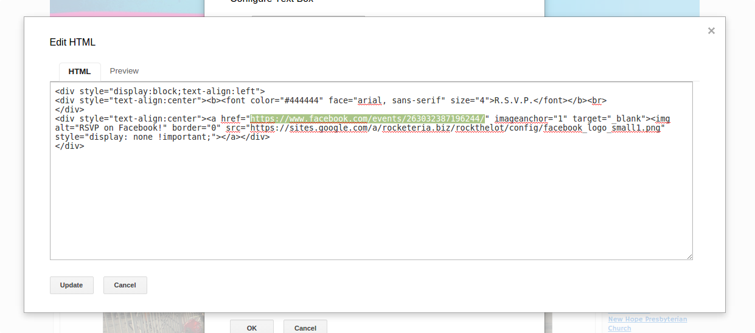

1. Click Update to exit the HTML editor
2. Click OK to edit the pop-up editor
3. Click the blue Close button in the header

# Main Content

## Making a New Page

Google does not allow you to change the default options for new pages, so some options must be set manually each time. To create a page:

1. Browse to [https://sites.google.com/a/rocketeria.biz/rockthelot](https://sites.google.com/a/rocketeria.biz/rockthelot/)
2. Click the Create Page button in the header
3. Enter name and choose a location for the page, then click the red Create button
4. After the new page loads, click the blue Save button in the header.
5. Drop down the gear menu at the top of the page and select Page Settings
6. In the pop-up dialog, uncheck all boxes, or if the page name should be shown at the top of the page, leave the “Show page title” box checked
7. If desired, edit the page description. This is the text that will appear, e.g., with the link to this page in Google results
8. Click Save

If desired, now enter Edit mode and add or complete the page content.

## Sponsors Page

### Add a Sponsor

In order to maintain the gray dotted table row separators, this process requires minor technical work. Follow the directions carefully.

1. Browse to <https://sites.google.com/a/rocketeria.biz/rockthelot/sponsors>
2. Click the pencil icon in the header to enter Edit mode
3. Click anywhere in the sponsor description text of the row *above* where a new sponsor is to be added (usually the last row)
4. In the menu, click Table > Insert row below. A new row will appear the row in which the cursor is sitting, but the row will be hard to identify as it will not have a dotted line below it.
5. Click just below the dotted row separator to highlight either cell of the new row

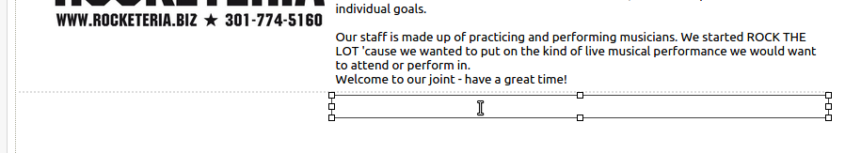

1. Add text as desired. **It is important to enter some text now** (dummy text may be used, but it should be easily identifiable text, e,g, “zzzzz” is more identifiable than “a”).
2. Click the <HTML> button to enter the source editor
3. Press ctrl+f (Mac ⌘+f) and use the Find utility to locate the text that was entered in this new row. The text will be surrounded by HTML, similar to the following:

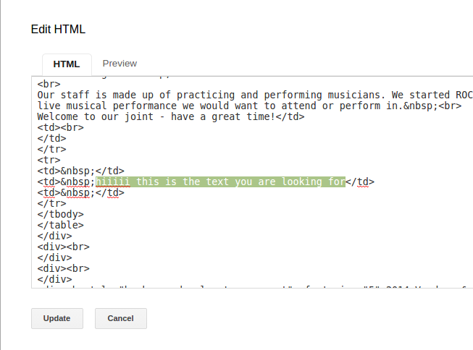

1. Select and copy the following text:

|  |
| --- |
| style="border-bottom-width:2px;border-bottom-style:dotted;border-bottom-color:rgb(221,221,221)" |

1. In the HTML editor, paste the text between the letters “td” and the closing bracket “>” that appear immediately before the text that was entered in this cell, *and also* in the same place within the “<td>” one line above it.

The lines should look as follows:

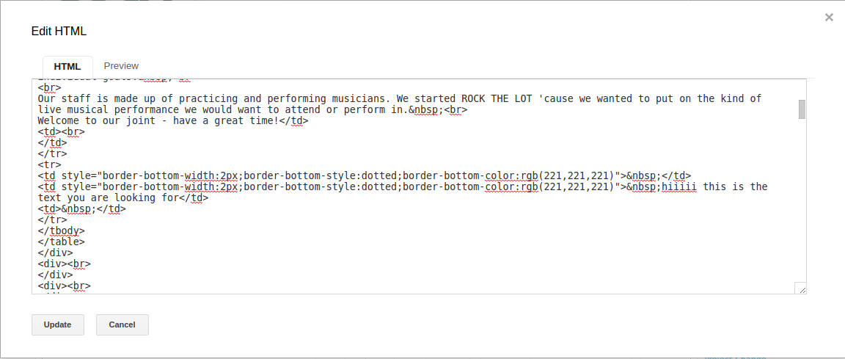

Identical image, with labels:

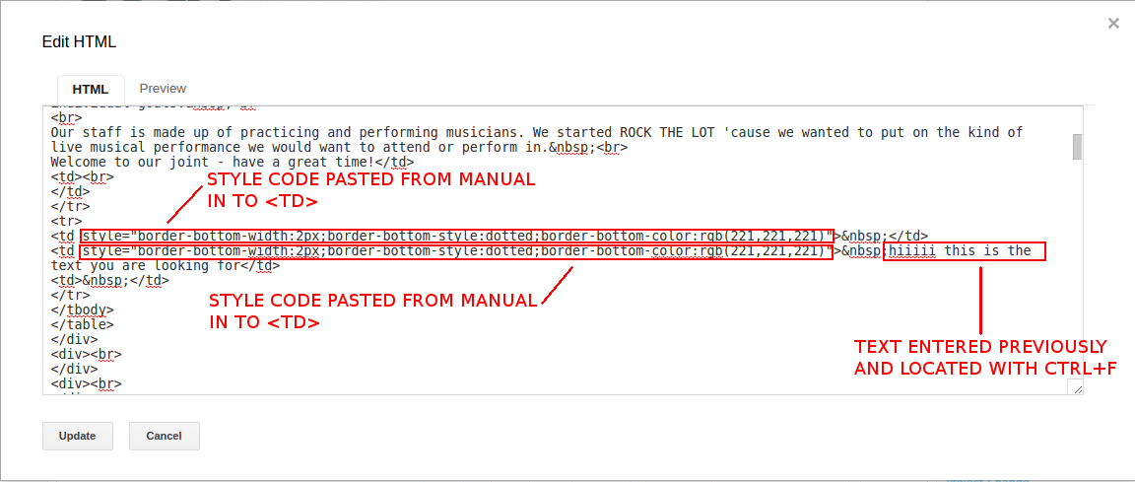

Note there should be a space between “td” and the code pasted from above, i.e.,

<td style=...

is correct and

~~<tdstyle=...~~

is wrong.

Do not paste the style code in any *closing* td blocks. Closing td blocks have a forward slash “/”, i.e., “</td>”. This would be wrong:

~~<~~**~~/~~**~~td style=...~~

1. Click Update. Inspect the table. If the dotted row separator does not appear, review the previous steps and attempt the edit again.
2. Now add the vendor image. Images should use the “M” (medium) or “S” (small) size and be center-justified. Images should also be links to the sponsor site, if applicable.

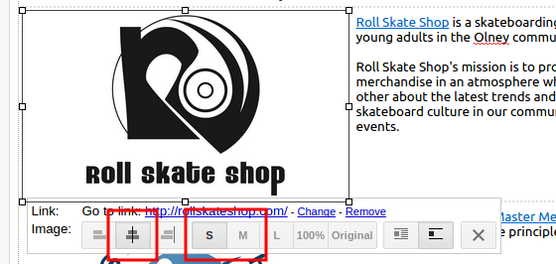

1. Click the blue Save button in the header

## Be a Sponsor Form

Editing the form requires minor knowledge of HTML. There is no non-technical way to edit the form fields. Please email the details of your change request to [kyle.c.steely@gmail.com](mailto:kyle.c.steely@gmail.com).

# Announcement Feed

## New Feed Post

1. Browse to <https://sites.google.com/a/rocketeria.biz/rockthelot/announcements>
2. Give the post a title and some content. Feed postings get very favorable treatment in Google search results. Use lots of buzz words with local meaning, like, “Olney”, “Olney Days”, “Parade”, etc.
3. Click the blue Save button in the header

# Special Needs Content

Google is improving stuff all the time, but at any given point there is a ton of gimpy shit. “Google Sites” is some hella gimpy shit. This section covers preferred methods of managing content that either can’t be added/edited in some obvious way, or looks lousy when added/edited in the obvious way.

This section is partly for Kyle’s own future reference**.** Some things here are more guidance than hand-holding instructions. Feel free to request something here be fleshed out.

## Photo Slide Show

### Kyle Personal Notes

The best way to do a slide show (as of 03/2015) is to make a Google Slides document with one image per slide, then get the iframe URL from the embed code and add an iframe object to the Sites page.

* To cover the largest available area without introducing black borders, use 100% width and 690 px height.
* Make sure the GET params include start=true&loop=true

There is a native “Slideshow” object, but it has giant black top & bottom borders, presumably to accommodate vertically oriented pics.

### Managing Photos

The slideshow pulls automatically from a Google Slides (like Powerpoint) document.

The current slideshow is pulling from:

<https://docs.google.com/a/rocketeria.biz/presentation/d/1rzQ9oVe62Q_OLKmnuEUMNw9Ful22s9qM51dTSqZqwGE/edit?usp=sharing>.

#### To delete an image

1. Browse to the Slides document
2. Right-click the slide in the left-hand navigation area and select Delete Slide

#### To add an image

1. Browse to the Slides document
2. Click the + button over the left-hand navigation and select Blank

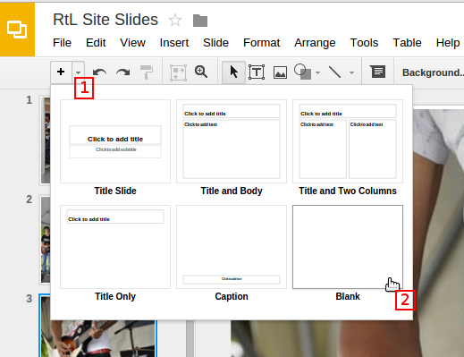

1. Click the image selection icon:



1. Browse to the image on your computer
2. Resize the image to fill the whole slide. Areas of the image that fall outside the boundary of the slide will be cropped from the slideshow.

That’s it - the slideshow widget pulls from this document automatically and does not need to be updated or refreshed in any way.

## YouTube Videos

At long last, the native YouTube objects look pretty decent. The only real issue is that there are a limited set of dimensions available. You can embed a video as an iframe if you need more control.

### Add a YouTube Video

1. Browse to <https://sites.google.com/a/rocketeria.biz/rockthelot/>
2. Navigate the the page where a video is to be added
3. Click the pencil icon in the header to enter Edit mode
4. In the header menu, click Insert > YouTube
5. Enter the video URL (just the regular link like you would send someone, not the embed link)
6. Uncheck the boxes for Include border and Include title
7. Select a size. The content area of the page is 881 px wide, so nothing larger than the 853x480 option should be used
8. Click Save
9. Back in Edit mode, click the new gray box that says YouTube Video and set the alignment and text wrap options as desired.
10. Click the blue Save button in the header